Building a Dataset

- Setup
  - Make sure your setup is stationed correct
  - Camera and mic array in a line, with the exact defined distance
  - The surface is leveled - you can use the Inclinometer to verify Pitch and Roll
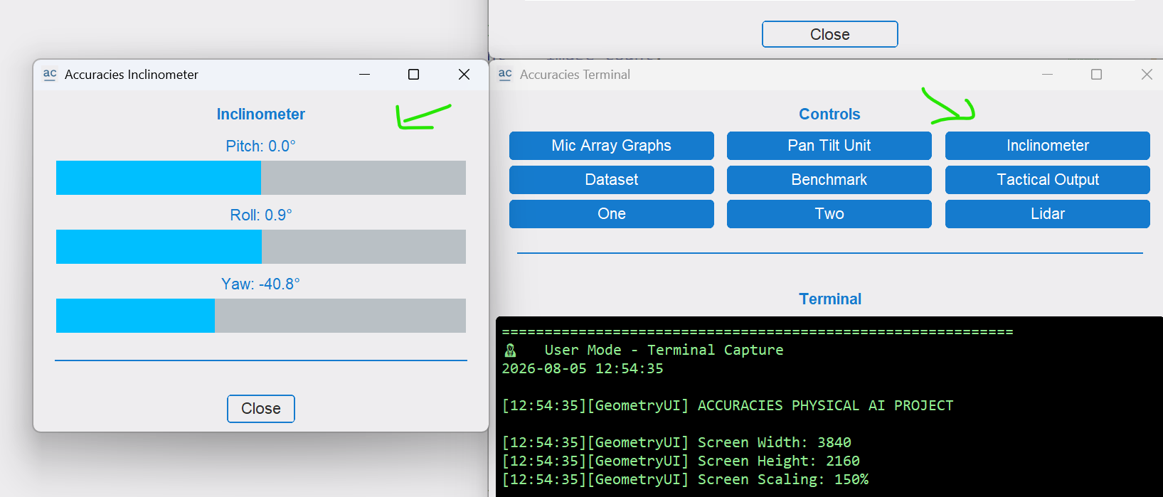

- Record a Dataset
  - Run
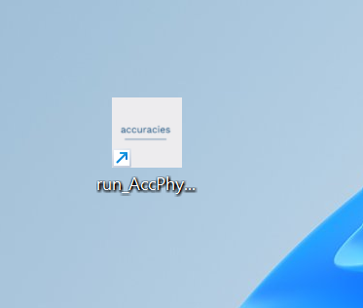

  - Main screen
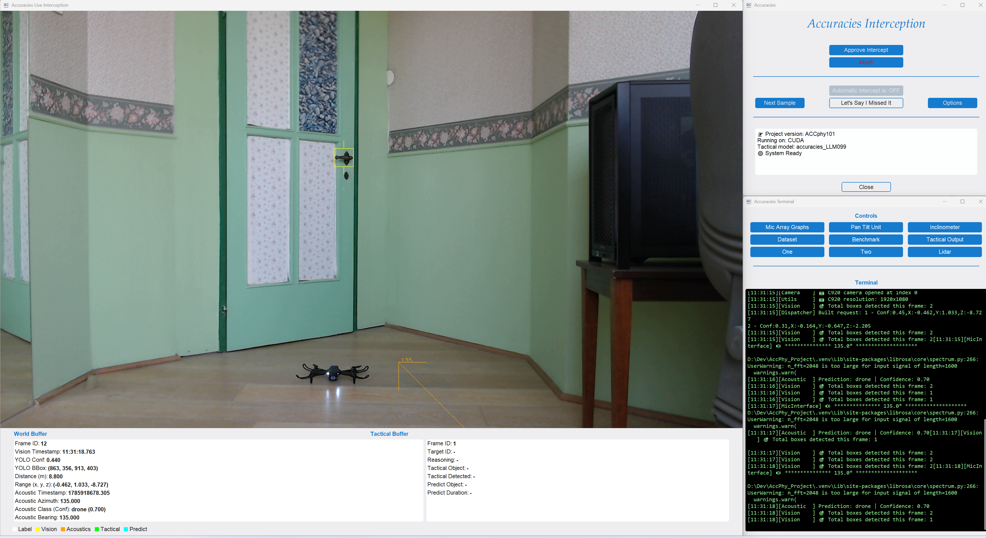

  - Click
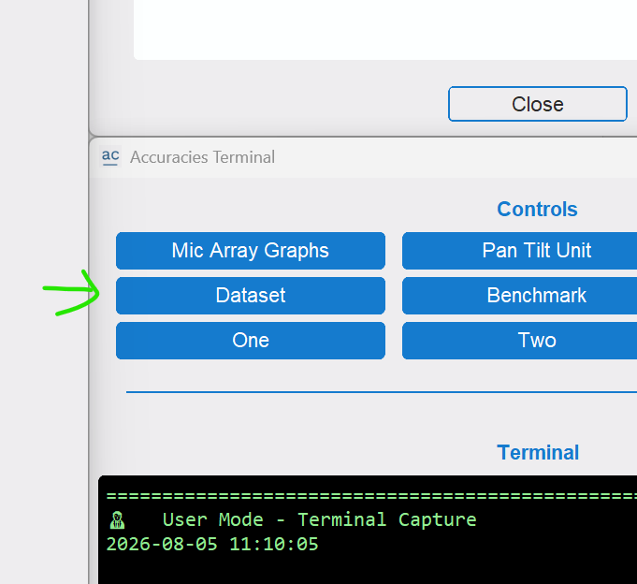
  - Click Acoustics Drone if you are recording a drone (acoustics, even if the drone is not in frame but can be heard) or Acoustics Noise – no drone sound
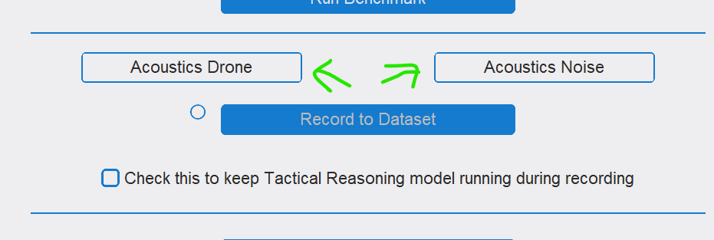
  - Keep it unchecked, it saves power (we check it only if we explicitly want the tactical results during recording and not afterward in processing)
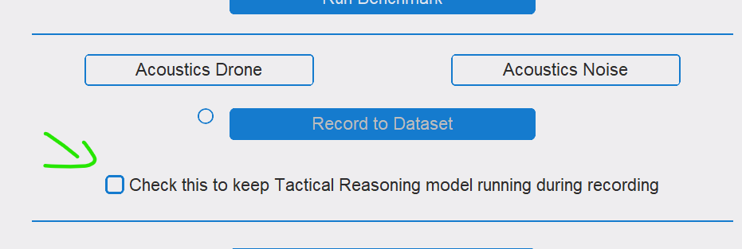
  - Make sure you are in Operational mode in Options window, note that when changing Mode, you need to close and reopen the program
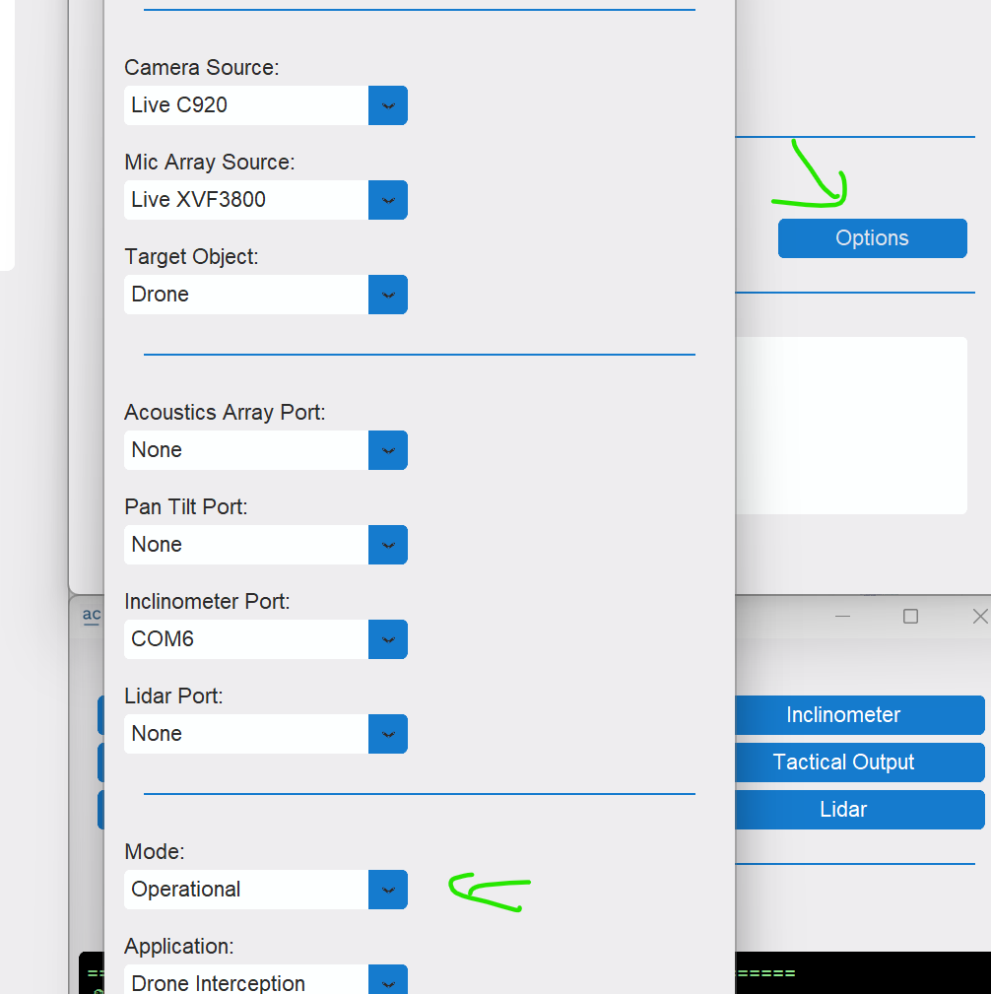

  - Start recording – the red light will turn on
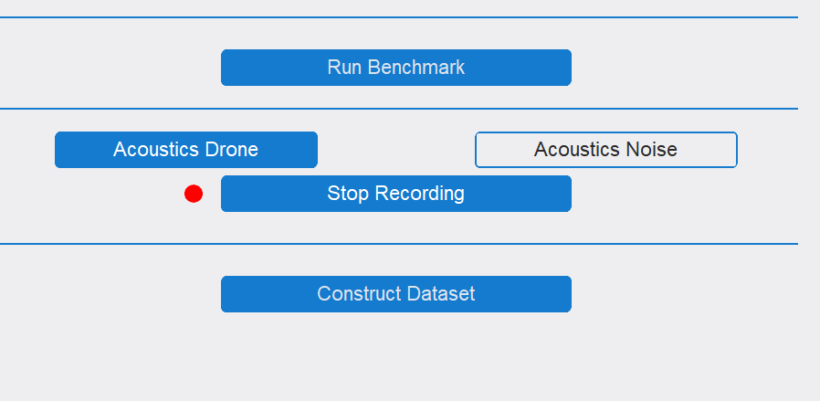

  - Stop the recording.
Now you can start another recording.
When you done change the mode to Research mode and close (if you forgot to change the mode, just open the program again change the mode and close)
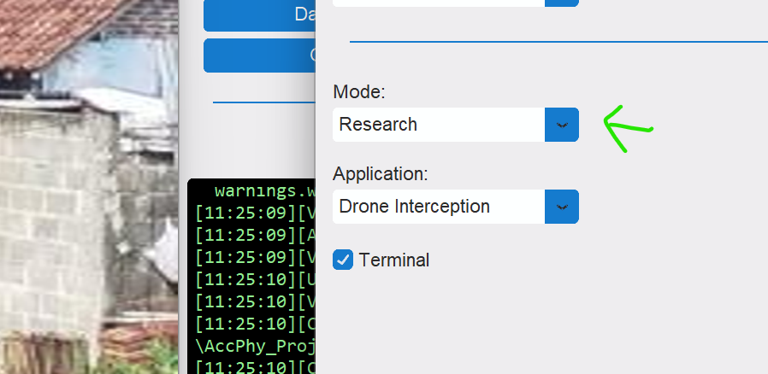

  - The recorded sets are under D:\Dev\AccPhy_Project\Datasets\Master_dataset\recorded_sets
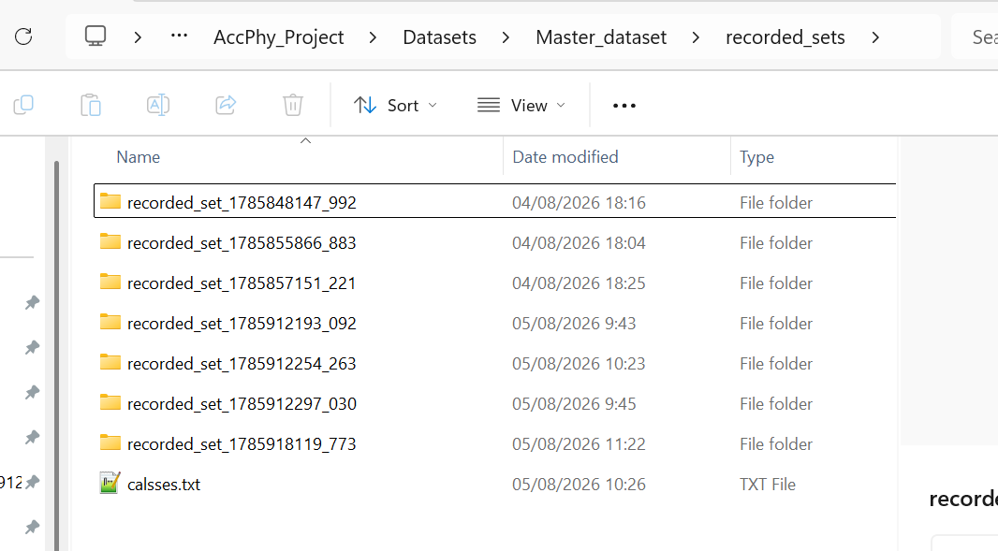

  - Inside each set, for each image there are 3 or 4 files
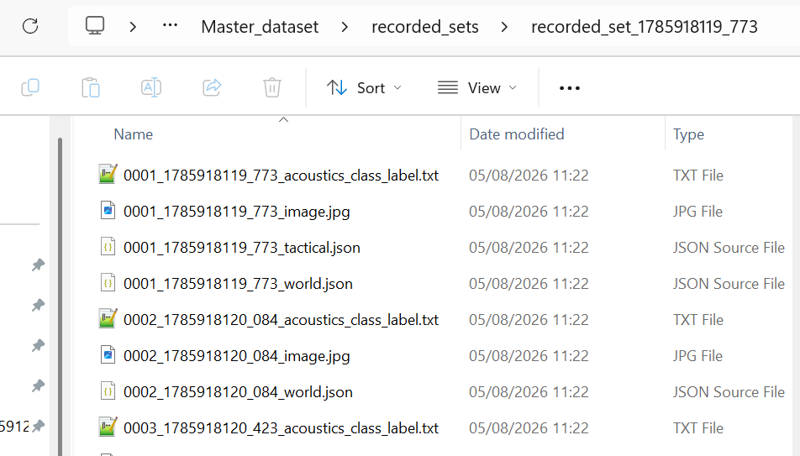

- Basic verify of the Dataset
  - Run, click Dataset and Construct Dataset
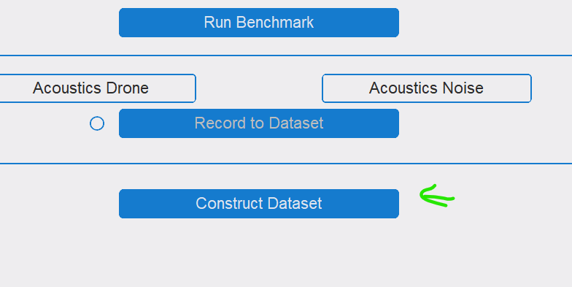

  - Click Folder Set and choose the Dataset you want to check
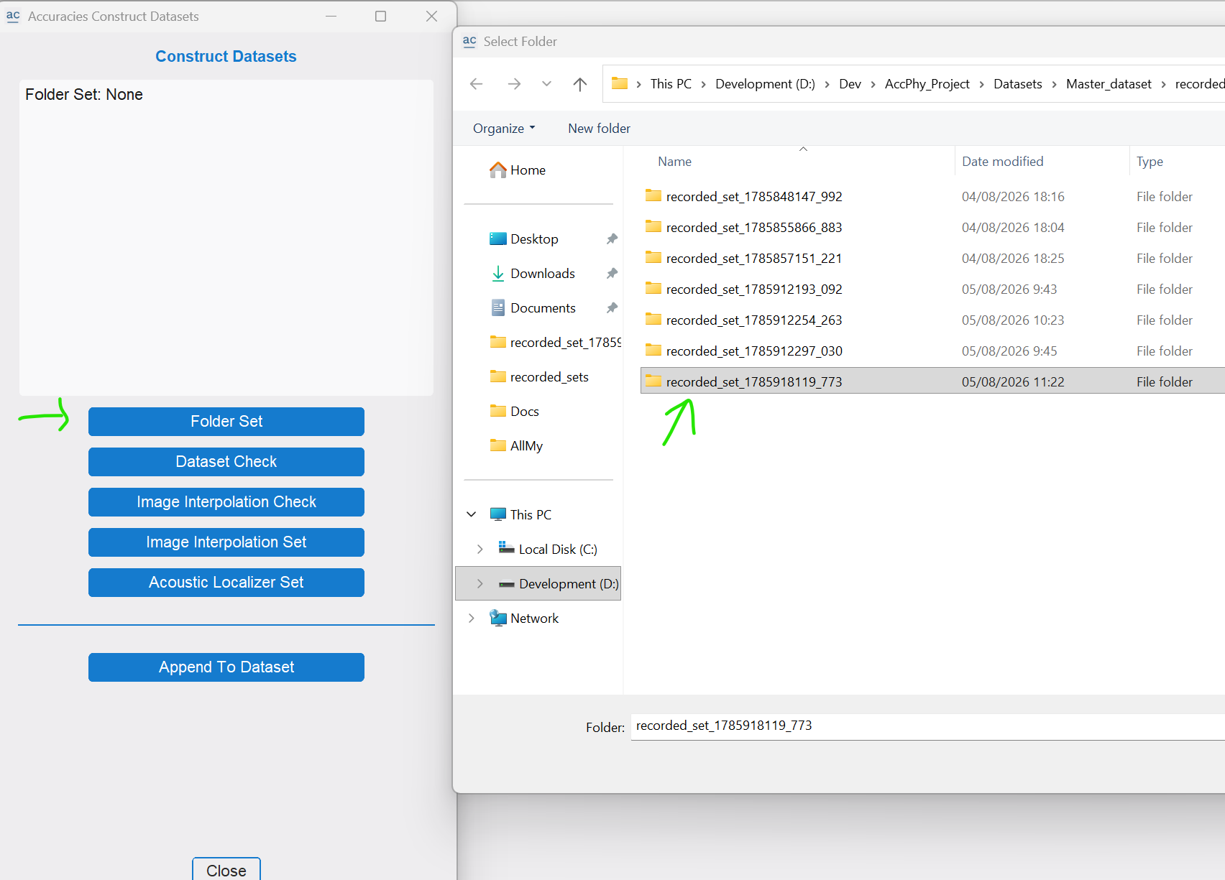

  - Click Dataset Check, what you can see is the number of files in the set, and that they match (Tactical is much less – and on a laptop it will be much less than the numbers you see in this picture) and more
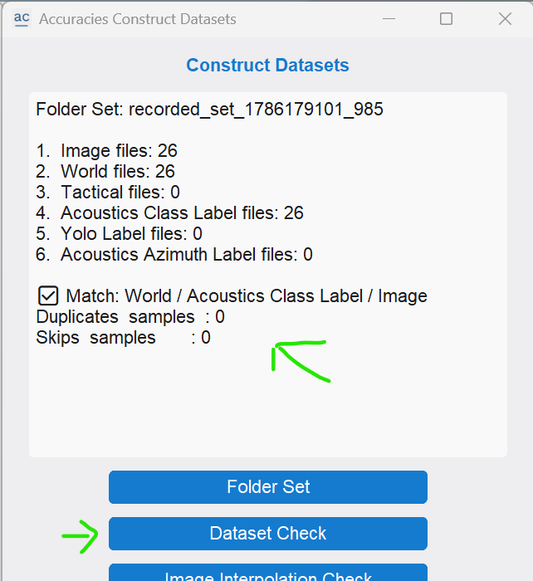

- Image Labeling - without AI model
  - Run X-AnyLabeling
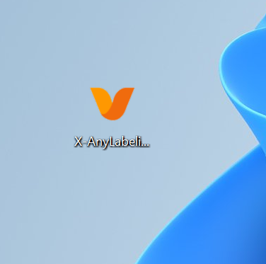

  - Click File and Open Dir, and open the dataset (one of the recordings folders)
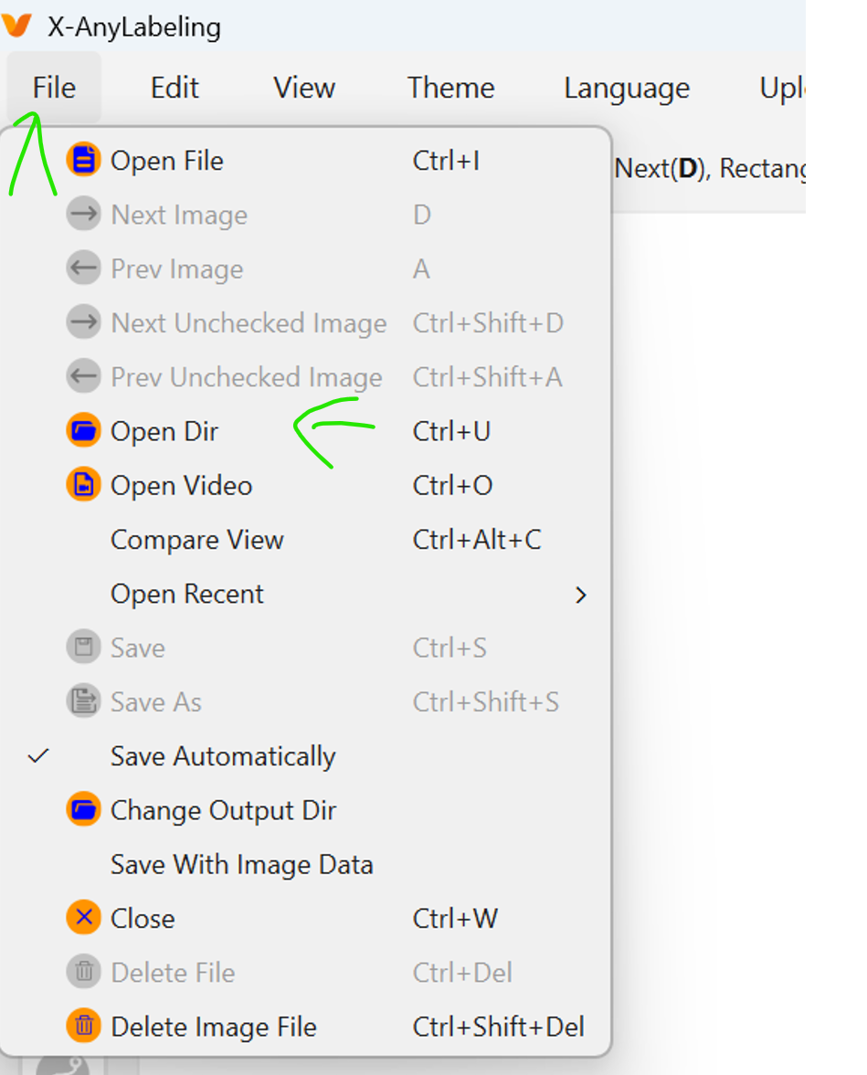

  - Choose the rectangular (or click R)
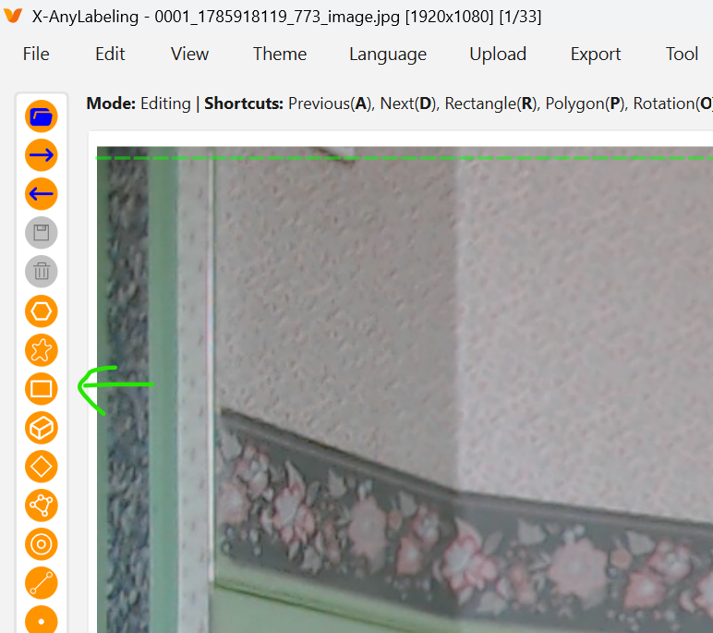

  - And mark the drone box (box is image label), first one corner
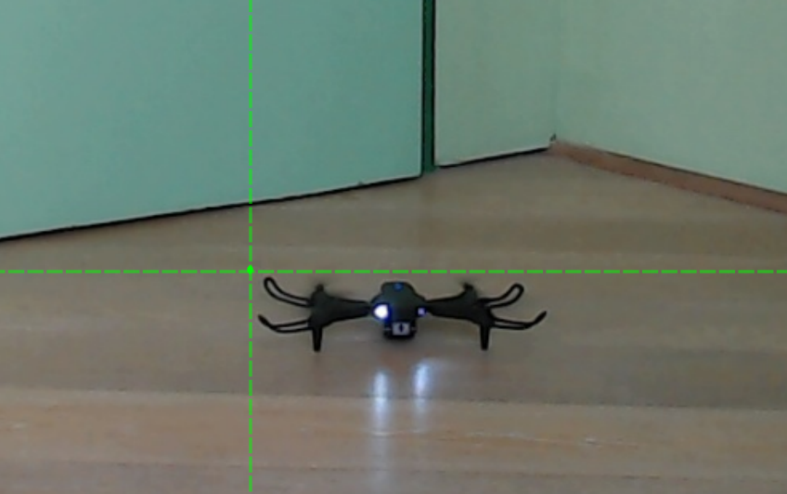

  - Then drag to the opposite corner, type Drone, and Click OK.
If it is a backgrounf image (no drone) then mark any triangle and type Noise
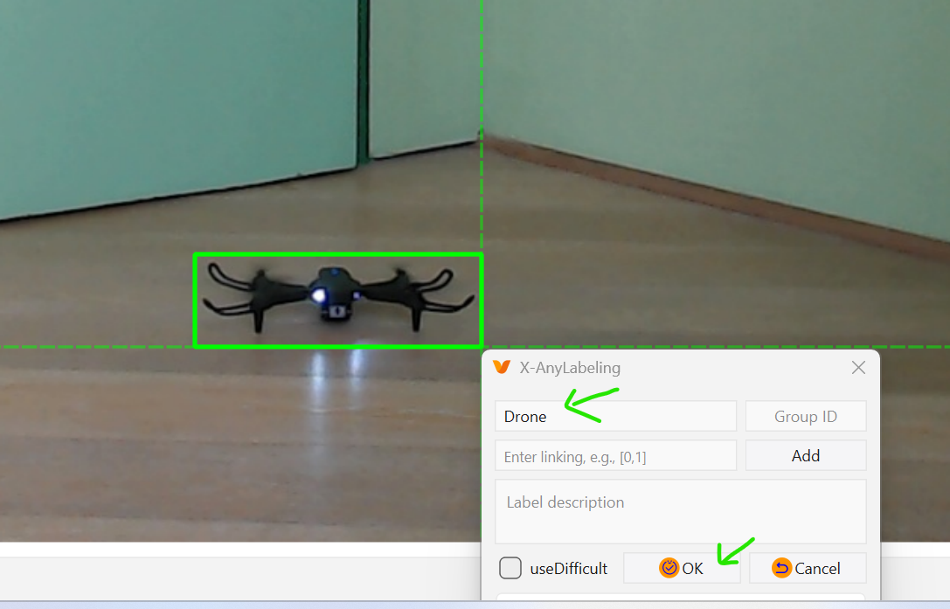

  - This image is labeled now. If there is more than one drone in the image, label the all
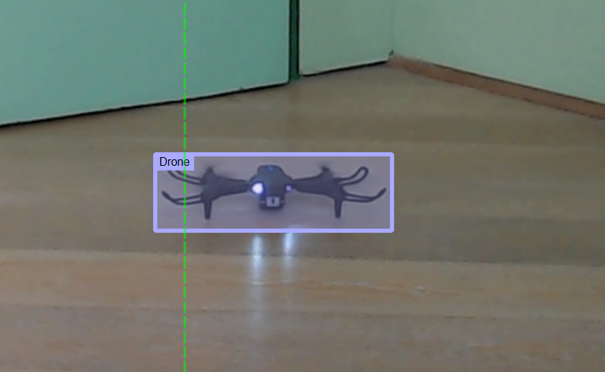

  - Now inside the folder a new json file was created
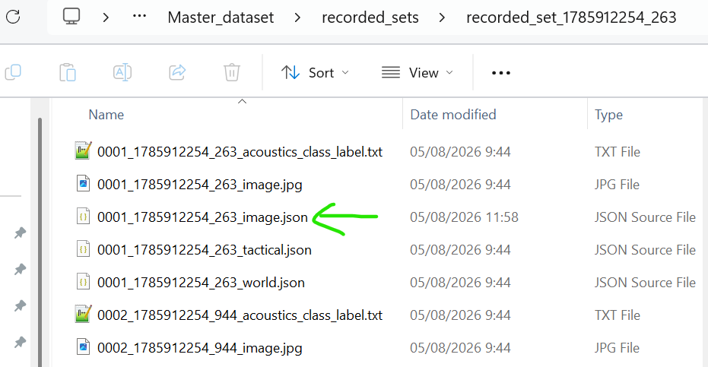

  - Mark Auto Use Last Label, so you don’t need to type Drone (or Noise) every time.
Make sure to manually type… when the images are switching between drone /noise
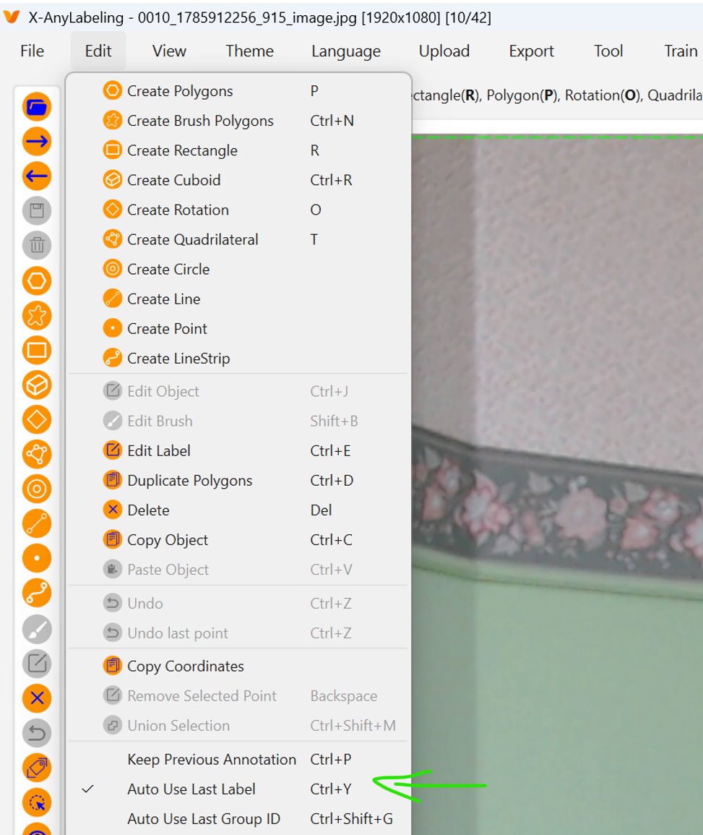

  - Now choose the next image to label (use the little arrows or click D), but don’t choose the next image in the list, we are going to implement interpolation on the images – that means adding labels automatically, so choose the next image that makes sense.
For example, the drone is flying in straight line, so the next image to choose is the one just before it makes a turn. Then the next one might be a closer one since it is flying in a circle, and so on.
Just think if you can draw a (more or less) straight line between the images.
Make sure you mark the first and the last image in the set.
Note the labels of the image before the gap and the image after the gap must be the same (drone/noise)
Note that anyway you can’t skip more than 10 images (we gave some restriction)
  - 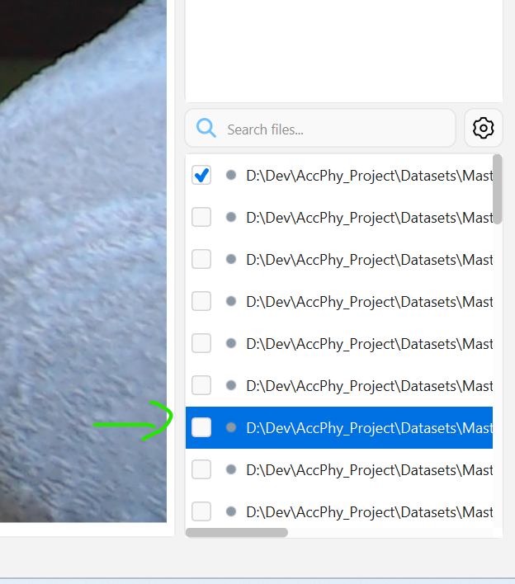

  - You can see the labeled files in the folder. Here you can see that the first two images in the skipped, but then I marked two in a row
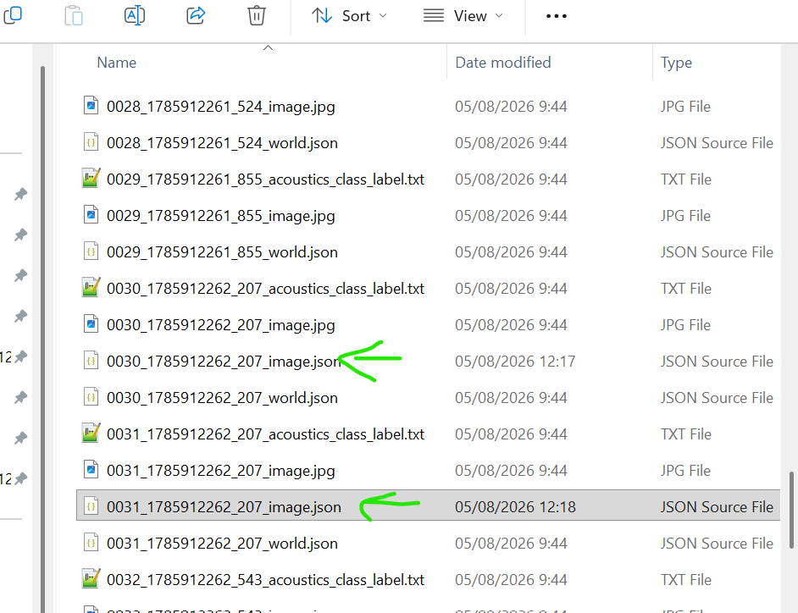

  - Export - we need to mark these convert these labels to YOLO (vision model) labels.
Export and YOL HBB
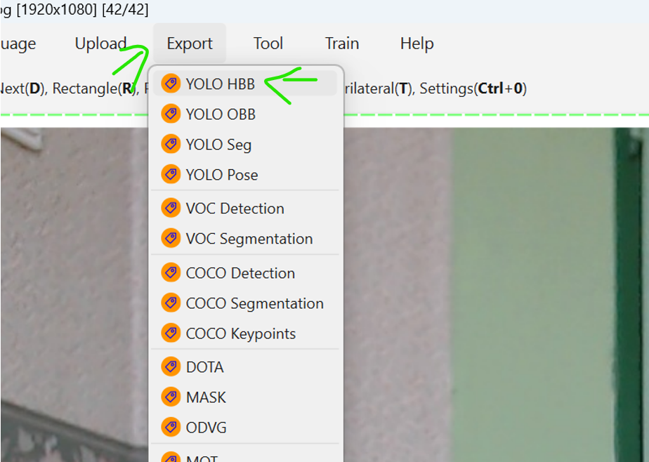

  - Choose classes.txt file under recorded_sets
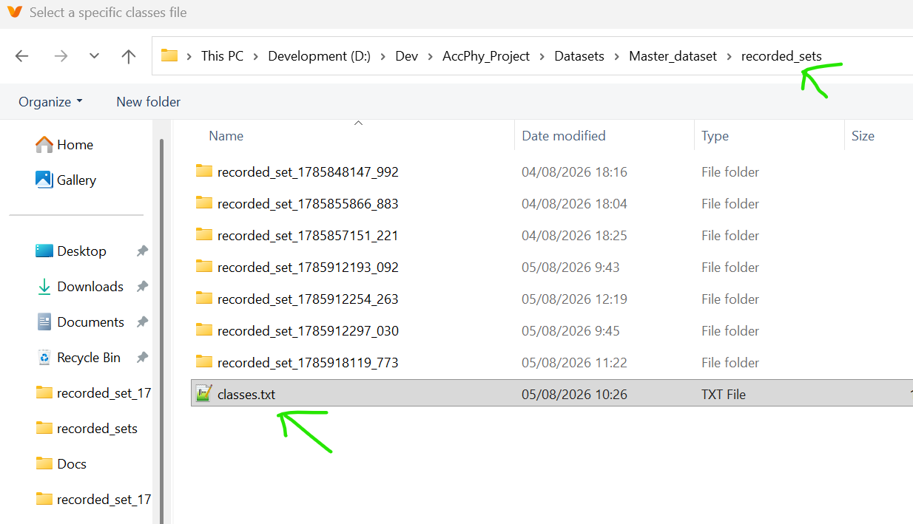

  - Browse to the set folder (we want to save the labels there)
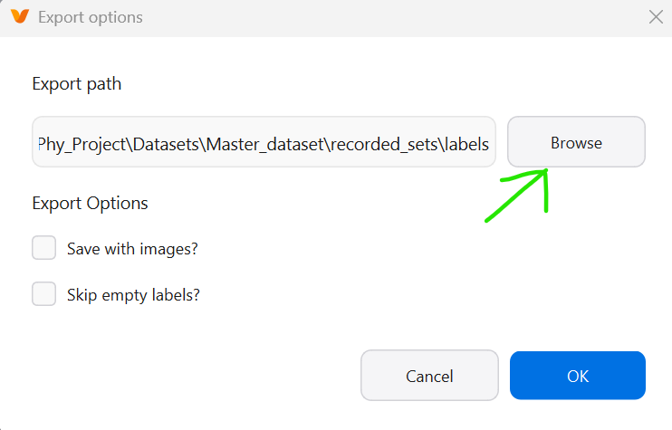
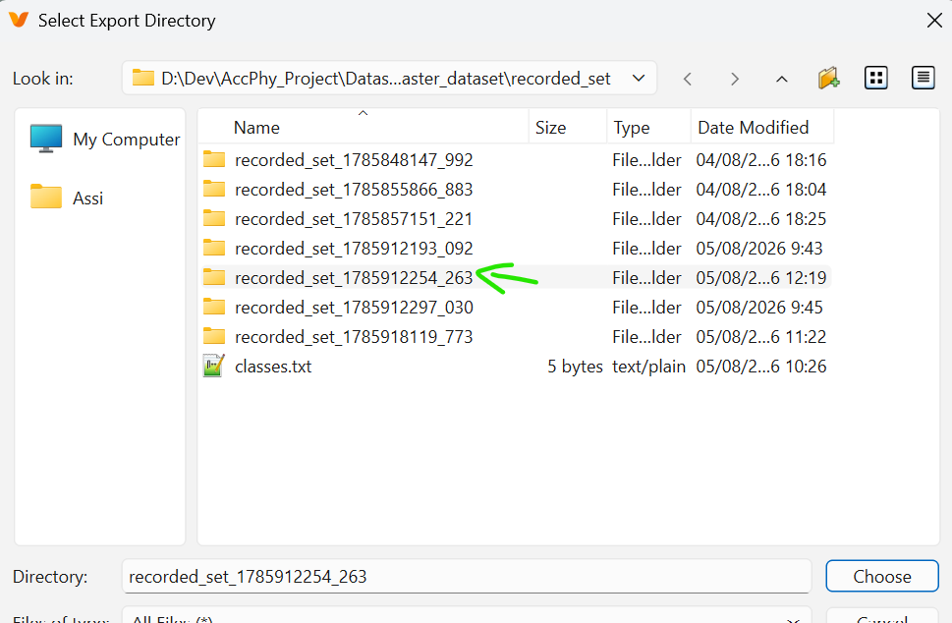

  - Mark Skip empty labels and OK
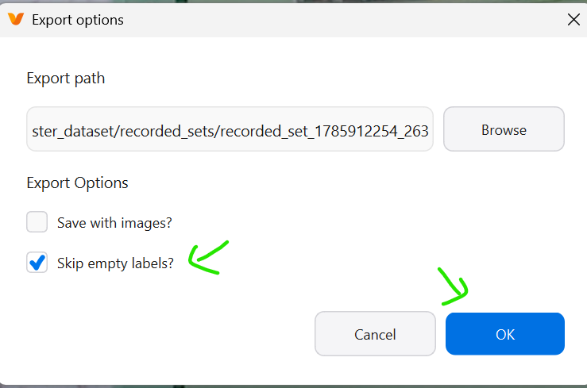
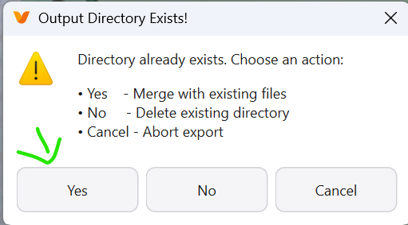

- Image Labeling - with AI model
  - Setting is done one time (or for every new model)
  - Export Accuracies YOLO model to ONNX format,
put the model in any folder (or /Datase folder) and run from there,
inside VSCode, in the .venv terminal :
yolo export model= detection_obyek_drone.v2i.yolo26.pt format=onnx
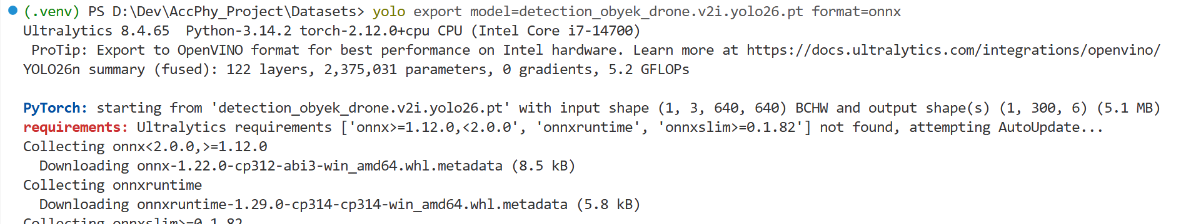
  - Prepare the for_anyLabeling.yaml file
  - Inside AnyLabeling click the AI icon and the models list button will appear
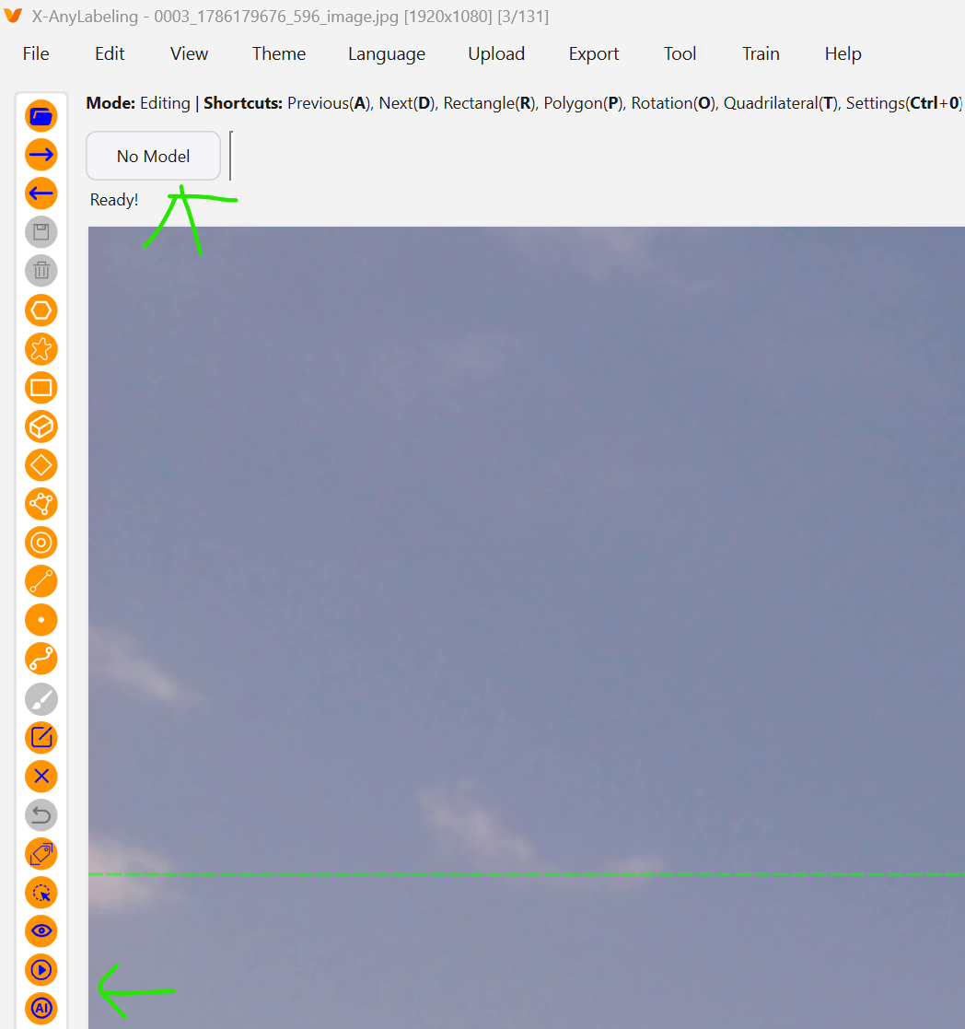
  - Click it and then choose ..Load Custom Model
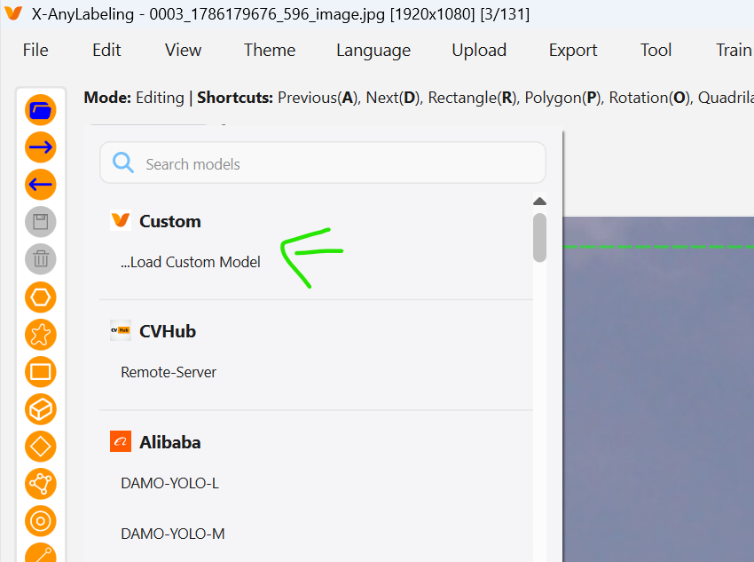
  - Choose the new yaml file
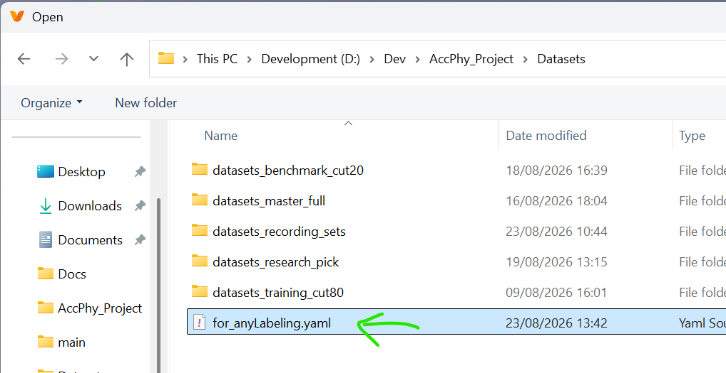
  - And you get the Accuracies Vision model
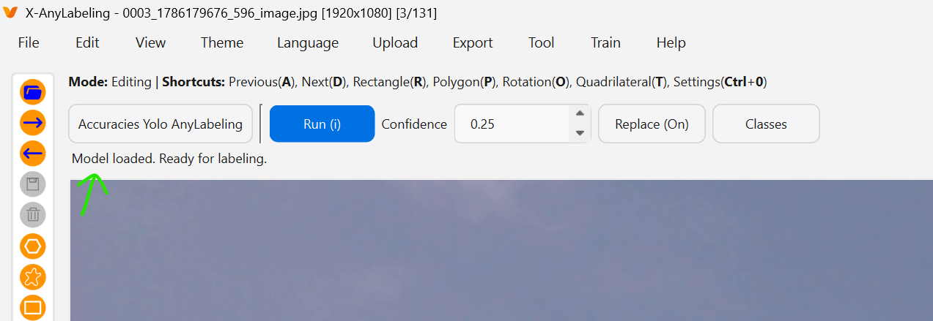
  - Run and play with Confidence to get the right box (or do it manually if it can’t find…)
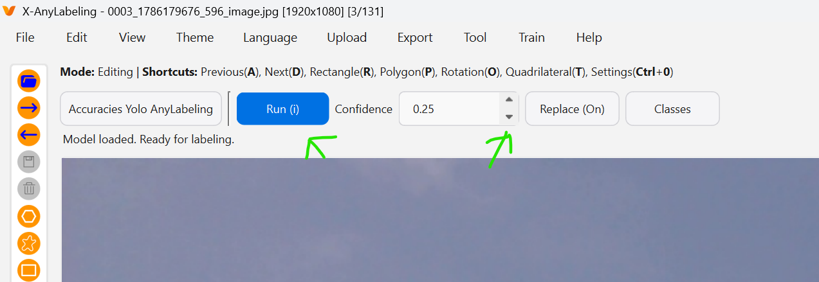

- Images Interpolation
  - Run Data Check now and you can see the number of labels you marked
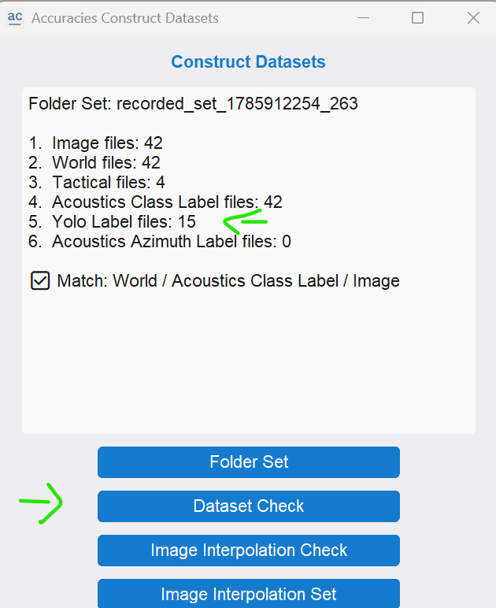

  - Run Image Interpolation Check, and you can see the gaps
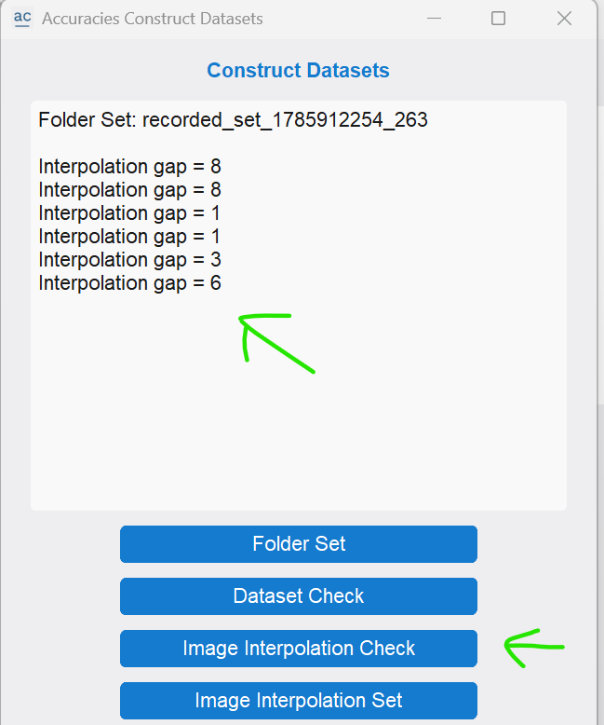

Run Image Interpolation Set.
This will fill the YOLO gap labels.
Note that this will also fill gaps where the drone flew behind a wall (assuming straight line in this version).
If it is not a straight line (for example, the drone came from the right but left from the top) then add labels in the way, this will divide the big gap to small gaps
(future version will handle curved paths, or non-constant speed).
Gap of multiple boxes in an image is not supported for now (can be done manually)
  - check labels - run Dataset Check to see that they all have labels now
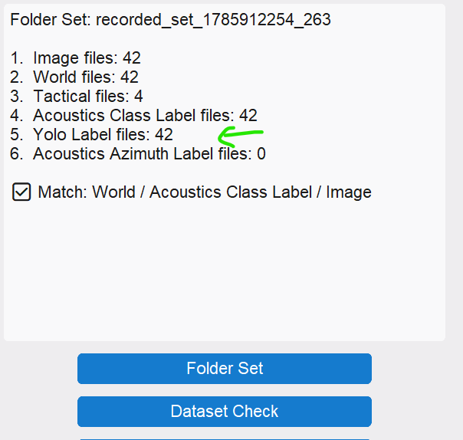

  - Verify and fix labels
Run Dataset, File and Open Dir, and open the dataset
use the arrows to go throw the images
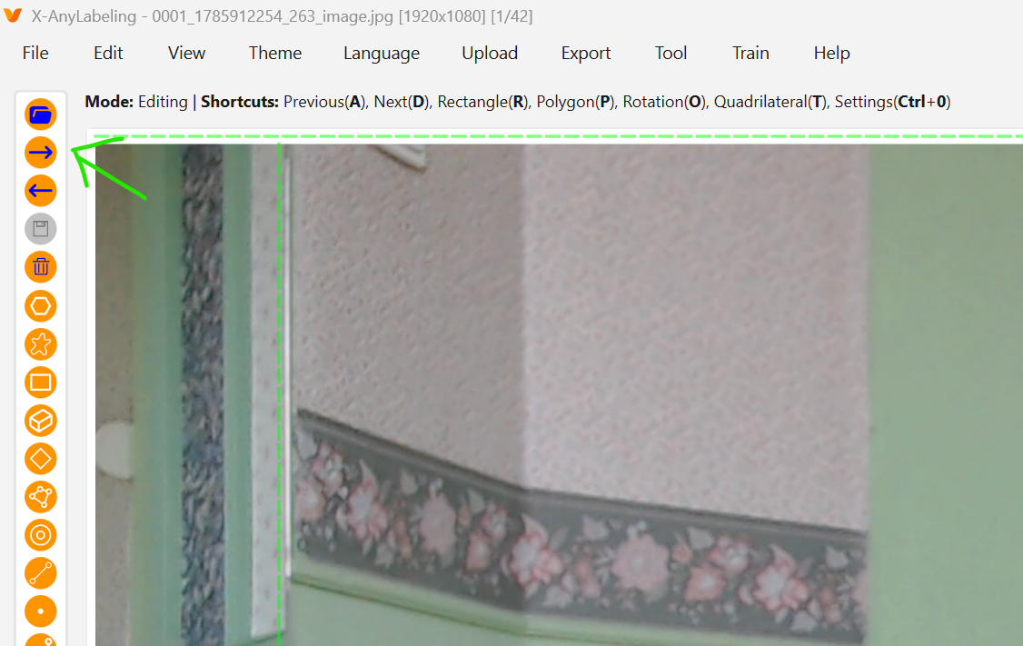

  - In case of an inaccurate label, just grab the box (there is a little hand showing – but couldn’t screenshot it) or take the corner and drag the to the right place.
And then Export the labels to YOLO like we did above
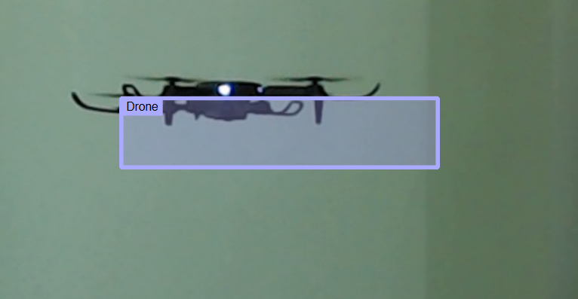
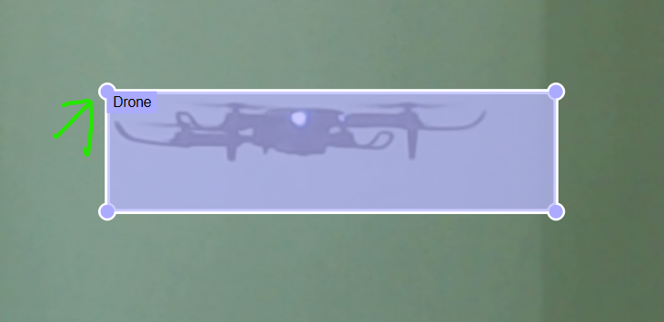
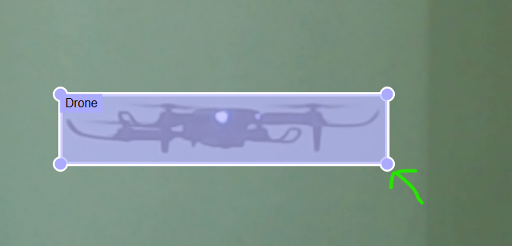

- Azimuth Set
  - Click to set the acoustics localizer (azimuth)
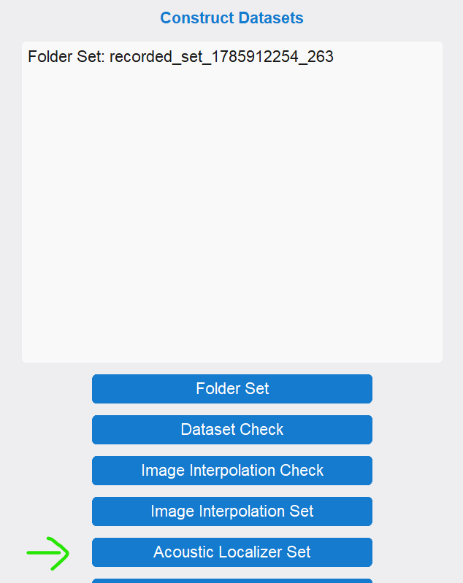

  - And check
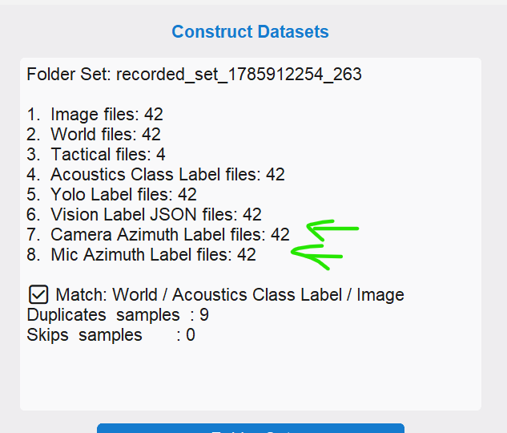

- Tactical Reasoning Set
  - Click Tactical Set,
it runs over the samples and saves each tactical correct answer to the Tactical training dataset, (or empty file if the answer is wrong)
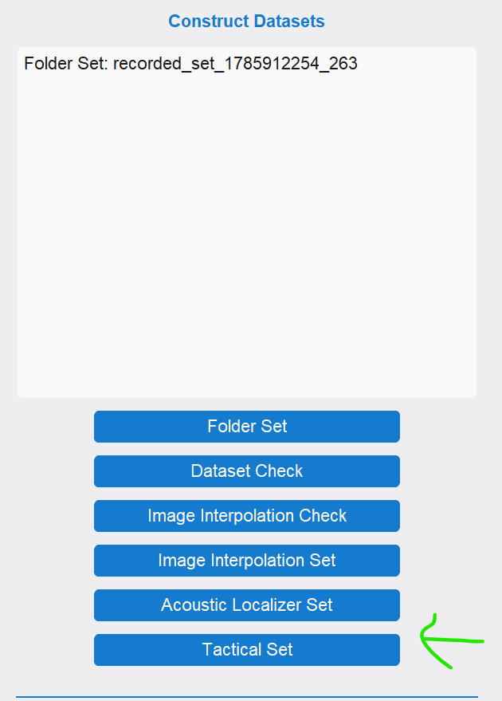

- Append to Datasets
  - This will add the selected to the clicked dataset folder
